CHE 507 Chemical Process Dynamics and Control

Final Exam

Professor Jang and Yao June 15, 2022

**Problem 1: (40 points)**

Consider the series **isothermal** chemical reaction system depicted in Figure 1. The following dynamic system holds:

$V_{1}\frac{dc_{A1}}{dt}=fc_{A0}-fc_{A1}-V_{1}kc_{A1}^{2}$

$V_{2}\frac{dc_{A2}}{dt}=fc_{A1}-fc_{A2}-V_{2}kc_{A2}^{2}$ (1)

Plus a feeding dynamic model, such that

$τ_{v}\frac{d}{dt}C_{A0}+C_{A0}=K_{v}M$ (2)

where $C_{A0}=c_{A0}-\overline{c_{A0}}, M=m-\tilde{m}$ are deviation variables of flowrate *f* and control signal from the DCS *m* respectively.

Assume that the outlet composition (CV) of the second tank , $c_{A2}(t)$, is on-line measured without any time delay and dynamics, and the inlet composition (MV) of reactant stream, $c_{A0}$*(t),(MV),* can be manipulated to control the output composition to a desired target.

The following parameters are available:

$$V_{1}=2.1m^{3}, V_{2}=1.8m^{3}, k=0.5\min^{-1}{\left(\frac{mole}{m^{3}}\right)}^{-1}{, K}_{v}=1\frac{\frac{mole}{m^{3}}}{\%}, τ_{v}=0.5min$$

And the following steady state:

$$\tilde{f}=0.085{m^{3}}/{min}, \overline{c_{A0}}=0.925\frac{mole}{m^{3}}, \overline{c_{A1s}}=0.236\frac{mole}{m^{3}}, \overline{c_{A2s}}=0.109\frac{mole}{m^{3}}$$

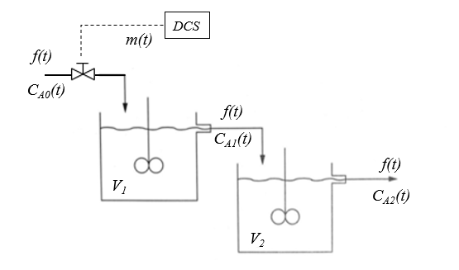

cA2(t)

cA1(t)

cA0(t)

AI

1. Linearize the above model, and derive the corresponding linear model with numerical values. To show the validity of your model, you can compare your model to the nonlinear system subject to a step change on $c_{A0}$ to 1.2 $\frac{mole}{m^{3}}$.
2. Transform the above three linear model to a third order model.
3. Derive the ultimate gain and ultimate period for your linearized model in (2).
4. What is the optimal P-only, PI and PID controller settings, respectively?
5. Perform a MATLAB simulation for the nonlinear system and compare the performance if you implement the controller settings obtained in (4). Note: you can implement idea PID controllers or discrete PID controller by assuming a comfortable sampling time.

,

Sol(1): Denote the deviation variables, $C_{A1}=c_{A1}-\overline{c_{A1}}$, $C_{A2}=c_{A2}-\overline{c_{A2}}$, $C_{A0}=c_{A0}-\overline{c_{A0}}$, *F=f*- $\overline{f}$

$\frac{dC_{A1}}{dt}=0.33F+0.04C_{A0}-0.276C_{A1}$

$\frac{dC_{A2}}{dt}=0.071F+0.04{7C}_{A1}-0.156C_{A2}$ (3)

1. 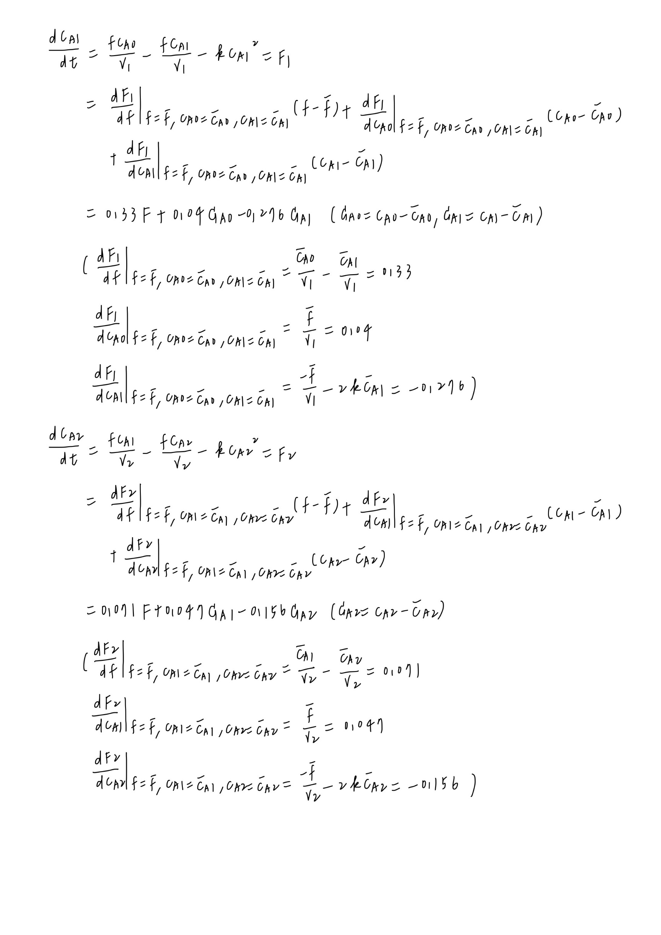Answer:
2. Rewrite the linearized model into a matrix for by assuming that the inlet composition is not changing, i.e. $F=0$

$\left[\begin{matrix}D+0.276 & 0 \\ -0.047 & D+0.156\end{matrix}\right]\left[\begin{matrix}C_{A1} \\ C_{A2}\end{matrix}\right]=\left[\begin{matrix}0.04 \\ 0\end{matrix}\right]C_{A0}$ (4)

Deleting $C_{A1}$ from (3), we have:

$\left\lceil \begin{matrix}D+0.276 & 0 \\ -0.047 & D+0.156\end{matrix}\right\rceil C_{A2}=\left\lceil \begin{matrix}D+0.276 & 0.04 \\ -0.047 & 0\end{matrix}\right\rceil C_{A0}$

Equivalently,

$\left(D^{2}+0.432D+0.431\right)C_{A2}=0.0019C_{A0}$ (5)

Further, By combing (2) and (5), we have:

$\left[\begin{matrix}D^{2}+0.432D+0.431 & -0.0019 \\ 0 & 0.5D+1\end{matrix}\right]\left[\begin{matrix}C_{A2} \\ C_{A0}\end{matrix}\right]=\left[\begin{matrix}0 \\ 1\end{matrix}\right]M$ (6)

By deleting $C_{A0}$ from (6):

$\left[\begin{matrix}D^{2}+0.432D+0.431 & -0.0019 \\ 0 & 0.5D+1\end{matrix}\right]C_{A2}=\left\lceil \begin{matrix}-0.0019 & 0 \\ 0.5D+1 & 1\end{matrix}\right\rceil M$

That yields:

(0.5000 $D^{3}$ +1.2160 $D^{2}$ + 0.6475D +0.4310) $C_{A2}$ =0.0019*M*